Git
- Git is a distributed version control and source code management system (SCM) or codebase.
- Git was initially designed and developed by Linus Torvalds for Linux kernel development in 2005
- Git is free software (open source) distributed.
- Git handles all levels of Java and non-Java projects.
- Workflow/Architecture:

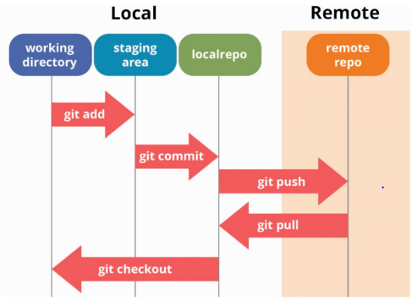
GitHub
- It is a git repository hosting service or web-based git repository. It provides a web-based graphical interface.
- GitHub is a cloud-based service that allows developers to store and manage their code and projects
- Difference between Git and GitHub:
Git | GitHub
Git is a Command-line tool | GitHub is a graphical user interface
Git is installed in locally on the system | GitHub is hosted on the web
Git is maintained by Linux | GitHub is maintained by Microsoft
Git is focused on Version Control and Code Sharing | GitHub is focused on centralized source code hosting
Git is a version control system to manages source code history | GitHub is a hosting service for Git repositories
Git was 1st released in 2005 | GitHub was launched in 2008
Git has no user management feature | GitHub has a build-in user management feature

